# Chapter 1

1. **A Copper bar with a diameter of 1.2cm and length 20cm is insulated with micanite which fits tightly around the bar and into the rotor slot of induction motor. Thickness of the micanite tube is 1.5mm and thermal resistivity is . Calculate the loss that will pass from copper bar to iron for a temperature difference of C maintained between them.**

**Solution:**

Diameter of Copper Bar, D = 12mm = 12*m

Thickness of Micanite Tube, t = 1.5mm = 1.5*m

Thermal Resistivity () =

Temperature difference, () = C

Length of Copper bar, L = 0.2m

Loss that will pass from copper bar to iron, = ()/

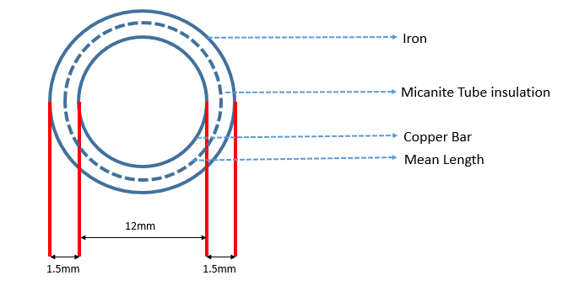

Thermal Resistance, =   
Surface area of insulation s = π*(D + t)*L = π*(12+1.5)**0.2 = 8.4823*

=  = 11.4147

= = 17.6715 W

1. **A 230V, 2.5KW single element resistor is made of a cylindrical nichrome wire. The temperature rise of strip should not exceed C over the ambient temperature of C Determine the length and diameter of strip assuming coefficient of emissivity() 0.9, radiating efficiency = 1 and resistivity of nichrome wire() as 0.424 .**

**Solution:**

Voltage = 230V; Power() = 2.5KW

Temperature of nichrome wire, = 1200 + 20 = C (Converted to absolute temperature as 1493K)

Temperature of Ambient medium, = C (Converted to absolute temperature as 293K)

Coefficient of emissivity () = 0.9

Radiating Efficiency () = 1

Stefan's Boltzmann constant,

Heat dissipated from material,

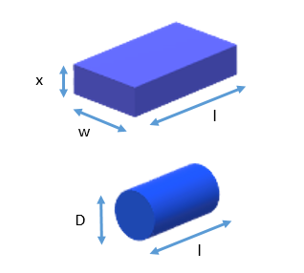

Resistance of nichrome wire, R = ()

R = 21.16

R = ()/A

A = (

------------------------------------------------------------------------------------------------- (1)

Total heat radiated,

= 3.1266* ----------------------------------------------------------------------------------------- (2)

Solve eq. (1) and eq. (2),

D = 0.0726m;L = 0.0430m

1. **The inner dimensions of the former field coil of a DC Generator are 150mm * 250mm. The former is 2.5mm thick. Calculate the heat conducted across the former from winding to core if there is an air space 1mm wide between the former and the pole core. The thermal conductivities of former and air are 0.166 and 0.05W/m- , respectively. The winding height is 200mm and the temperature rise is 40 .**

**Solution:**

Thickness of field coil, = 2.5mm

Thickness of air space, = 1mm

Winding height = 200mm

Thermal conductivity of the field coil, = 0.166W/m-

Thermal conductivity of the air, =0.05W/m-

Temperature rise, = 40

Heat conducted across the field coil, = (

Thermal resistance, = + (i.e., sum of thermal resistance of field coil and air coil)

=

=

=

= (2.5*/ (0.166*0.16)

= 0.094

= (1*/ (0.05*0.16)

= 0.125

= 0.094 + 0.125 = 0.219

= (40/0.219) = 182.6484

1. **Calculate the heating time constant of 10KVA transformer during a heat run test, if the temperature rise after one hour and two hours is found to be 35 and 47.5, respectively.**

**Solution:**

Temperature rise of transformer after one hour = 35

Temperature rise of transformer after two hour = 47.5

Temperature Rise,

At t=1, 35 = ---------------------------------------------------------------------------------------- (1)

At t=2, 47.5 = -------------------------------------------------------------------------------------- (2)

Div eq(2) and eq(1)